**The Ultimate Full-stack .NET Developer Bundle**

Master all the .NET skills you need to land a full-stack developer job

Top of Form

[Enroll in Course for ~~$399~~ $119](https://sso.teachable.com/secure/146684/checkout/993430/the-ultimate-full-stack-net-developer-bundle?coupon_code=CSBNDLTAG)

Bottom of Form

**Limited time at this price**

**First-rate Courses at a Bargain Price**

To land a full-stack development job, you need to be skilled in more than one area of coding. This bundle covers absolutely every detail you could possibly need to become an expert full-stack .NET developer.

7

COURSES

35

HOURS

**Clear, concise, comprehensive, and practical with no fluff,  
packed with real-world examples, exercises and solutions.**

* Save over $200 (No joke!)
* Expand your career options
* Prepare for technical interviews
* Learn little known expert tips
* Get certificates of completion
* Unlimited access
* Learn at your own pace
* Watch online or download
* Watch on any device
* Learn shortcuts to write code fast

**You'll learn to how to build real websites using  
C#, Entity Framework and ASP.NET MVC**

No more boring courses that waste your time with so much  
unnecessary theory or teach you how to make to-do apps!

I share tips from several years’ experience using C#, Entity Framework and ASP.NET MVC including the do’s and don’ts, best practices, common mistakes and practical shortcuts that every professional .NET developer needs to know.

**Courses Included with Purchase**



**Complete SQL Mastery**

Master the SQL statements that every software developer needs for designing, developing and maintaining databases

Mosh Hamedani

**$149**



**The Complete ASP.NET MVC 5 Course**

Learn to build and deploy fast and secure web applications with ASP.NET MVC 5

Mosh Hamedani

**$149**

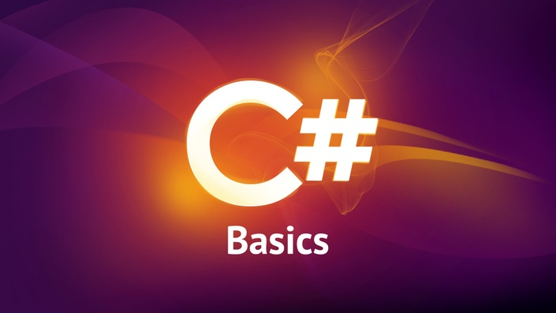

**C# Basics for Beginners**

Learn the fundamentals of programming with C# with tons of exercises and real-world examples

Mosh Hamedani

**$59**

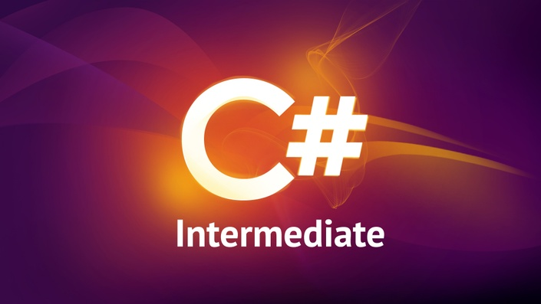

**C# Intermediate: Classes, Interfaces and Object-oriented Programming**

An in-depth, step-by-step guide to classes, interfaces and object-oriented programming, with many real-world examples.

Mosh Hamedani

**$59**

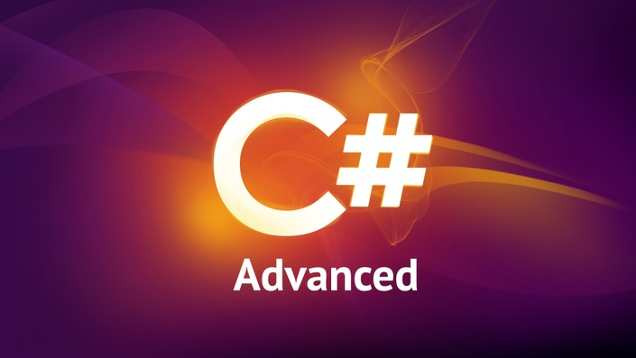

**C# Advanced: Get Ready for Job Interviews**

The advanced C# constructs that every C# coder must know: Events, Delegates, Lambda Expressions, LINQ, Async and more

Mosh Hamedani

**$59**



**Unit Testing for C# Developers**

Master unit testing - an essential skill for anyone who wants to become a senior developer

Mosh Hamedani

**$149**



**Clean Coding and Refactoring**

Learn the secrets the experts use to write and maintain perfect code

Mosh Hamedani

**$99**



**Entity Framework 6 in Depth**

Connect your applications  
to a SQL Server database

Mosh Hamedani

**$59**

**Original Price: $782**

**Your Instructor**



**Mosh Hamedani**

Hi! My name is Mosh Hamedani. I'm a software engineer with almost **two decades of experience** and I've taught **over three million people**how to code or how to become a professional software engineer through my online courses and YouTube channel.

I believe **coding should be fun** and accessible to everyone.

**Prerequisites**

The courses in this bundle assume no prior experience. Everything is covered from scratch.

**Frequently Asked Questions**

**When does the course start and finish?**

The course starts now and never ends! It is a completely self-paced online course - you decide when you start and when you finish.

**How long do I have access to the course?**

How does lifetime access sound? After enrolling, you have unlimited access to this course for as long as you like - across any and all devices you own.

**What if I am unhappy with the course?**

We would never want you to be unhappy! If you are unsatisfied with your purchase, contact us in the first 30 days and we will give you a full refund.

**Do you want to become a  
professional full-stack developer?**

Stop wasting your precious time following random and disconnected tutorials  
from different instructors. Purchase this bundle and learn it all from Mosh.

* 35 hours of HD videos
* Exercises and fully explained solutions
* Little known expert tips and secrets
* Common mistakes to avoid
* Best practices that pros use
* Unlimited access
* Learn at your own pace
* Watch online or offline
* Watch on any devices
* Certificate of completion